OIST Graduate University
Policies, Rules and Procedures

Authority: Approved by the CEO

Chapter 43 OIST University Press

43.1 Policy
The OIST University Press (OISTUP) publishes scholarly works to further the University’s purpose in promoting internationally distinguished research and education in science and technology, contributing to the promotion and development of Okinawa, and developing science and technology worldwide, for the benefit of humanity. Publications include print, electronic, and other forms. Users of OISTUP include the research and administrative divisions and staff of the University and the general public. OISTUP is an unincorporated entity within the Graduate University, reporting to the CEO.

43.2 General Considerations
The OISTUP is a service for the OIST community and for public, academic, and other users who contribute to the OIST mission.

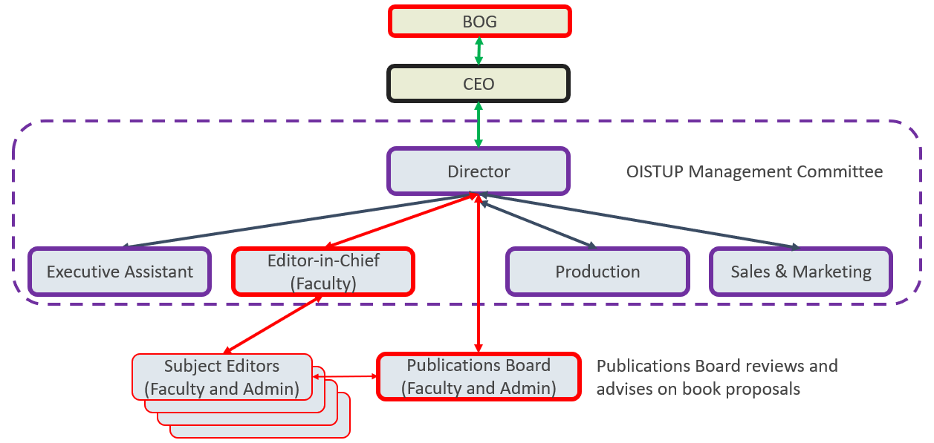

43.3 Rules
43.3.1 Management
The Director of OISTUP is appointed by the CEO. Positions on the OISTUP Management Committee and the Publications Board are proposed by the Director of OISTUP and appointed by the CEO.

43.3.2 Publication Conditions
Publication is carried 0ut under copyright and related rules in the OIST PRP and relevant legal requirements. OIST General Council provides guidance to OISTUP on matters of legal rights and responsibilities.

43.3.3 Eligibility
43.3.3.1 University Related.
University organizations and individual University faculty, students, and staff may submit proposals for publication.

43.3.3.2 External Users.
External organizations or individuals may submit proposals for publication.

43.3.4 Budget and Accounting
43.3.4.1 Annual Budget.
The Director of OISTUP must request annual budget for the operation of OISTUP, in accordance with the general budget request procedures approved by the CEO. External revenue income must be included in the budget proposal.

43.3.4.2 Internal Users.
Proposals for publications must include royalties and costs as well as sources of budget.

43.3.4.3 External Users.
Proposals for publications must include royalties and costs as well as payment plans.

  - Responsibilities
- The Director of OISTUP is responsible for all operations of OISTUP, working with the Editor-in-Chief, Executive Assistant, Production Team, Sales and Marketing Team, and Publications Board.
- The Editor-in-Chief is responsible for recommending books, articles, and other media for publication to the Director, on the advice of the Publications Board.
- The Publications Board is responsible for reviewing proposals and providing input to the Editor-in-Chief.
- The Subject Editors are responsible for reviewing the manuscripts and media based on their expertise and reporting on the results of their review to the Editor-in-Chief.
- The Production Team is responsible for producing approved manuscripts and media through to final publication according to the production schedule.
- The Sales and Marketing Team is responsible for the promotion of OISTUP and for the sales, marketing, and distribution of OISTUP publications.

43.5 Procedures
- All procedures shall conform to OIST PRPs.
- Proposals for publications are submitted to OISTUP in a standard format, and after preliminary editorial review, are evaluated by the Publications Board. Publication is approved by the Director of OISTUP based on the recommendation of the Publications Board.
- Budget, costs, royalties, payments, etc. shall be managed according to OIST accounting rules and other relevant requirements.

43.6 Forms
Publication Proposal Form

43.7 Contacts
43.7.1 Policy Owner:
The CEO

43.7.2 Other Contacts:
Director of OISTUP

